Diagnosis of fatty liver in children should occur in parallel to investigation for other causes of liver disease
Joint statement ESPGHAN and EASL

Fatty liver is the most common chronic liver disease in European children. Historically, non-alcoholic fatty liver disease (NAFLD) evolved as a diagnosis of exclusion, in which the presence of hepatic steatosis (with or without inflammation and fibrosis) in the absence of an alternative cause (particularly alcohol) led to the diagnosis of NAFLD. Hepatic steatosis has long been recognised as a manifestation of a wide array of conditions, ranging from viral hepatitis, autoimmune liver disease, Wilson’s disease, α1-antitrypsin deficiency, and rarer metabolic disorders.1 Hepatic steatosis is associated with extra-hepatic conditions such as coeliac disease, cystic fibrosis, malnutrition, systemic diseases, various drugs, and parenteral nutrition. Therefore, to make a diagnosis of NAFLD, these conditions must first all be excluded.2
Increasing familiarity with investigating and managing individuals with fatty liver has shown that there are some features that positively confer a diagnosis of NAFLD. Insulin resistance is a key underlying feature of the metabolic syndrome and is almost ubiquitously associated with NAFLD in a bidirectional relationship.3 Insulin resistance can be covert (unless using clamp studies), therefore other surrogates have taken its place, such as obesity and dyslipidaemia. These are key components of the metabolic syndrome, which is characterised by the presence of obesity, insulin resistance, hyperlipidaemia, and hypertension. NAFLD is commonly considered as the liver manifestation of the metabolic syndrome. These observations have been replicated in hundreds of cohorts of adults and children internationally.4,5
Consequently, it is possible to positively make a diagnosis of fatty liver disease associated with features of the metabolic syndrome, which has been termed metabolic dysfunction-associated fatty liver disease (MAFLD) in the first publications.6 The original definition of MAFLD stipulates the presence of hepatic steatosis in addition to one of the following: (1) overweight or obesity; (2) presence of type 2 diabetes; or (3) evidence of metabolic dysregulation. There is currently no established definition of metabolic syndrome in children, which infers a positive diagnosis of NAFLD in those with steatosis in the context of other features of the metabolic syndrome.7 However, the name MAFLD remains controversial and there is now a multi-stakeholder consensus process tasked with identifying the best name to replace NAFLD. Moreover, although new proposed names and definitions might provide a more accurate description of the underlying pathophysiological processes, they also allow for the opportunity for individuals to have more than one diagnosis, including fatty liver disease related to insulin resistance (eg, an individual with obesity, insulin resistance, and a fatty liver in addition to chronic viral hepatitis). However, fundamentally, co-existent diagnoses need to be ruled out in children and young people.
Clear criteria for making a positive diagnosis with MAFLD provides the opportunity for clinicians to focus on this condition. These criteria could mean that in some clinical contexts (eg, individuals living with obesity and type 2 diabetes with a bright liver on ultrasonography and slightly increased aminotransferases), clinicians might decide that tests for autoimmune, viral, or inherited metabolic disease are not all needed. Although this might be more likely to occur in adult hepatology clinics, this shift could also occur in paediatric care.8 The occurrence of this shift in paediatric care would be inappropriate because, for children, the risk and consequences of missing other liver disorders are different. For example, from nearly 350 children referred by primary care physicians for suspected fatty liver to a tertiary liver centre in the USA, 61 (18%) had an alternative diagnosis.9 Given its peak in presentation during adolescence and young adulthood, the prior probability of diagnosis of Wilson’s disease is higher in teenagers than in adults.
In children, a positive diagnosis of fatty liver should go in parallel with the investigation for other causes of chronic liver disease (fifigure), ensuring that dual pathology is not missed (eg, an individual with obesity and coeliac disease or a teenager with obesity, insulin resistance, and autoimmune hepatitis). With a 20% prevalence of obesity in children and teenagers in the USA, the co-existence of fatty liver related to insulin resistance with another chronic liver disease (dual cause chronic liver disease) is increasingly likely.
Unlike NAFLD, the treatment of which is challenging, many other disorders (eg, viral hepatitis, Wilson’s disease, and coeliac disease) have specific and often highly efficacious therapies. Many of the classical mimics of fatty liver have characteristic histological patterns; for example, predominance of microvesicular steatosis in lysosomal acid lipase deficiency and swollen periodic acid-Schiff positive hepatocytes in glycogen storage disease.10 Moreover, a missed (or late) diagnosis of such a condition has a greater cumulative effect on quality of life. Conversely, the cumulative lifetime effect of a missed diagnosis (eg, of autoimmune hepatitis) is lower in an older patient than in a child. Autoimmune hepatitis, for example, is known to have a more aggressive course in young patients than in older patients. Paediatricians should send a similar panel of investigations for patients with fatty liver disease when making a positive diagnosis (ie, MAFLD) or a diagnosis of exclusion (ie, NAFLD).
Clinical assessment is required to decide how extensively to investigate everyone with hepatic steatosis or mildly abnormal liver enzymes. All children need a baseline set of investigations. Lean individuals; those with more marked elevation in aminotransferases (eg, ALT >300 IU/L) or clinical or radiological signs suggestive of chronic liver disease (eg, splenomegaly); and those younger than 8 years would typically warrant more extensive investigations (including liver biopsy), which has been discussed elsewhere.11
The European Society for Paediatric Gastroenterology Hepatology and Nutrition and the European Association for the Study of the Liver wholeheartedly endorse the move towards positively conferring a diagnosis of fatty liver secondary to insulin resistance. When assessing children with hepatic steatosis, whether or not concomitantly abnormal liver blood tests are present, other causes of liver disease should be looked for even if children have features of the metabolic syndrome (eg, obesity). This will ensure that serious, treatable diagnoses (eg, Wilson’s disease) are not missed in children with overweight and obesity. We are fully supportive of the ongoing global multi- stakeholder Delphi process to ensure consensus is reached regarding a name and definition that allows for a positive identification of fatty liver related to insulin resistance.
European Society for Paediatric Gastroenterology Hepatology (ESPGHAN) and European Association for the Study of the Liver (EASL), on behalf of co-authors*
Correspondence: j.p.mann@bham.ac.uk
*Co-authors are listed in the appendix.

Refs:
1 Nobili V, Alisi A, Valenti L, Miele L, Feldstein AE, Alkhouri N. NAFLD in children: new genes, new diagnostic modalities and new drugs.
Nat Rev Gastroenterol Hepatol 2019; 16: 517–30.
2 Vos MB, Abrams SH, Barlow SE, et al. NASPGHAN clinical practice guideline for the diagnosis and treatment of nonalcoholic fatty liver disease in children: recommendations from the Expert Committee on NAFLD (ECON) and the North American Society of Pediatric Gastroenterology, Hepatology and Nutrition (NASPGHAN). J Pediatr Gastroenterol Nutr 2017; 64: 319–34.
3 Samuel VT, Shulman GI. Nonalcoholic fatty liver disease as a nexus of metabolic and hepatic diseases. Cell Metab 2018; 27: 22–41.
4 Vajro P, Lenta S, Socha P, et al. Diagnosis of nonalcoholic fatty liver disease in children and adolescents: position paper of the ESPGHAN Hepatology Committee. J Pediatr Gastroenterol Nutr 2012; 54: 700–13.
5 European Association for the Study of the Liver (EASL), European Association for the Study of Diabetes (EASD), European Association for the Study of Obesity (EASO). EASL-EASD-EASO Clinical Practice Guidelines for the management of non-alcoholic fatty liver disease. J Hepatol 2016;
64: 1388–402
6 Eslam M, Sanyal AJ, George J, et al. MAFLD: A consensus-driven proposed nomenclature for metabolic associated fatty liver disease. Gastroenterology 2020; 158: 1999–2014.
7 Eslam M, Alkhouri N, Vajro P, et al. Defining paediatric metabolic (dysfunction)-associated fatty liver disease: an international expert consensus statement. Lancet Gastroenterol Hepatol 2021; 6: 864–73.
8 Kotha S, Berry P. Multiple investigations for a very common disorder: finding the right balance in NAFLD. J Hepatol 2021; 75: 1501–02.
9 Schwimmer JB, Newton KP, Awai HI, et al. Paediatric gastroenterology
evaluation of overweight and obese children referred from primary care for suspected non-alcoholic fatty liver disease. Aliment Pharmacol Ther 2013; 38: 1267–77.
10 Liebe R, Esposito I, Bock HH, et al. Diagnosis and management of secondary causes of steatohepatitis. J Hepatol 2021; 74: 1455–71.
11 Hegarty R, Deheragoda M, Fitzpatrick E, Dhawan A. Paediatric fatty liver disease (PeFLD): all is not NAFLD—pathophysiological insights and approach to management. J Hepatol 2018; 68: 1286–99.

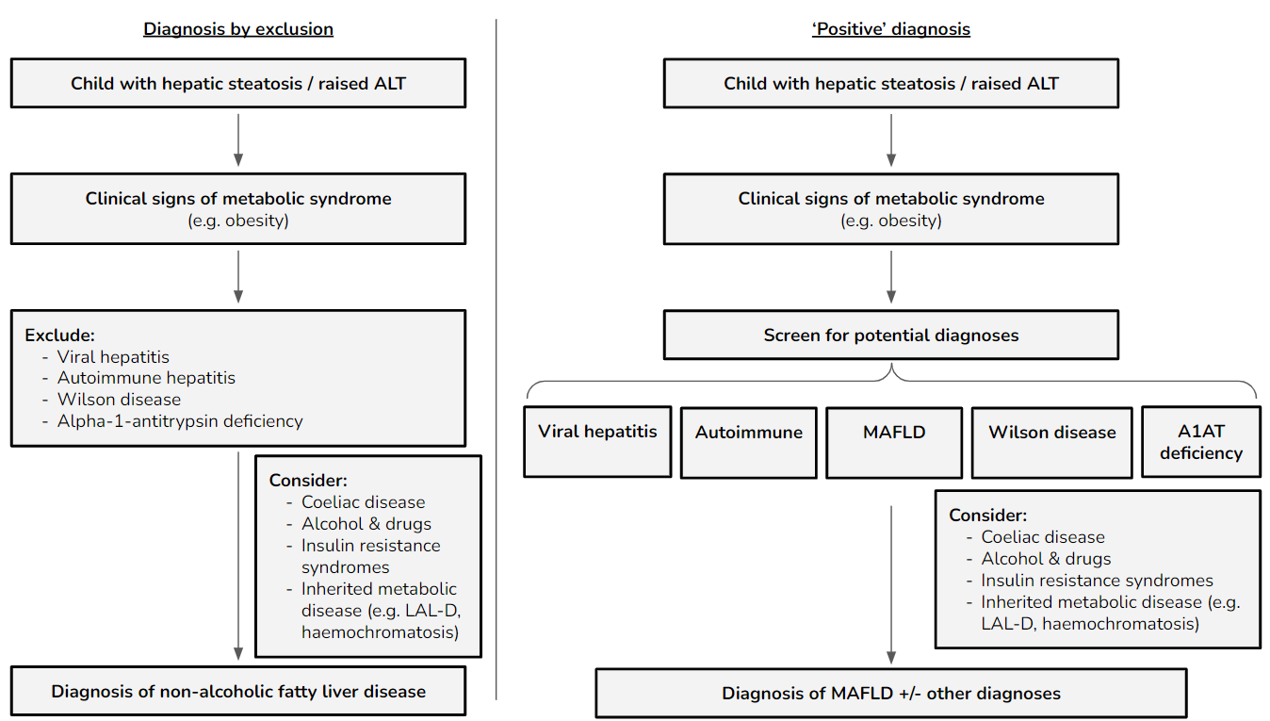
Figure: A model for investigation of other causes of liver disease while positively making a diagnosis of MAFLD.
The investigation for other potential causes should be done in parallel to testing for MAFLD, which facilitates diagnosing dual cause, where appropriate. ALT=alanine aminotransferase. MAFLD=metabolic dysfunction-associated fatty liver disease. NAFLD=non-alcoholic fatty liver disease.

